**Supplementary Material**

**Table S1.** List of species recorded, their families and successional stage (assigned according to Kanowski et al. (2010). For species absent from this database successional stage was assigned based on experience. If successional stage could not be confidently assigned it was removed from the determination of the successional metrics.

|  |  |  |  |  |  |
| --- | --- | --- | --- | --- | --- |
| Species | Code | Family | Origin | Habit | Successional stage |
| *Alangium villosum* | Ala_vil | ALANGIACEAE | native | tree | L |
| *Euroschinus falcatus* | Eur_fal | ANACARDIACEAE | native | tree | EM |
| *Rhodosphaera rhodanthema* | Rho_rho | ANACARDIACEAE | native | tree | M |
| *Alyxia ruscifolia* | Aly_rus | APOCYNACEAE | native | shrub | ML |
| *Carissa ovata* | Car_ova | APOCYNACEAE | native | shrub | M |
| *Tabernaemontana pandacaqui* | Tab_pan | APOCYNACEAE | native | shrub | EML |
| *Polyscias elegans* | Pol_ele | ARALIACEAE | native | tree | EM |
| *Schefflera actinophylla* | Sch_act | ARALIACEAE | exotic | tree | M |
| *Araucaria cunninghamii* | Ara_cun | ARAUCARIACEAE | native | tree | EML |
| *Archontophoenix spp* | Arc_spp | ARECACEAE | native | tree | L |
| *Linospadix monostachya* | Lin_mon | ARECACEAE | native | tree | L |
| *Argophyllum nullumense* | Arg_nul | ARGOPHYLLACEAE | native | shrub | ? |
| *Nandina spp* | Nan_spp | BERBERIDACEAE | exotic | shrub | ? |
| *Jacaranda mimosifolia* | Jac_mim | BIGNONIACEAE | exotic | tree | EM |
| *Tecoma capensis* | Tec_cap | BIGNONIACEAE | exotic | shrub | ? |
| *Tecoma stans* | Tec_sta | BIGNONIACEAE | exotic | tree | EM |
| *Canarium australasicum* | Can_aus | BURSERACEAE | native | tree | ML |
| *Senna pendula* | Sen_pen | CAESALPINIACEAE | exotic | shrub | EM |
| *Senna septemtrionalis* | Sen_sep | CAESALPINIACEAE | exotic | shrub | EM |
| *Senna spp.* | Sen_spp | CAESALPINIACEAE | exotic | shrub | EM |
| *Senna sulfurea* | Sen_sul | CAESALPINIACEAE | native | shrub | EM |
| *Capparis arborea* | Cap_arb | CAPPARACEAE | native | shrub | ML |
| *Casuarina cunninghamiana* | Cas_cun | CASUARINACEAE | native | tree | EM |
| *Casuarina littoralis* | Cas_lit | CASUARINACEAE | native | tree | ML |
| *Pleurostylia opposita* | Ple_opp | CELASTRACEAE | native | tree | M |
| *Pseudoweinmannia lachnocarpa* | Pse_lac | CUNONIACEAE | native | tree | L |
| *Cordyline spp* | Cor_spp | DRACAENACEAE | native | shrub | ML |
| *Diospyros australis* | Dio_aus | EBENACEAE | native | tree | ML |
| *Diospyros ellipticifolia* | Dio_ell | EBENACEAE | native | tree | ML |
| *Diospyros fasciculosa* | Dio_fas | EBENACEAE | native | tree | ML |
| *Diospyros geminata* | Dio_gem | EBENACEAE | native | tree | ML |
| *Diospyros pentamera* | Dio_pen | EBENACEAE | native | tree | ML |
| *Diploglottis australis* | Dip_aus | EBENACEAE | native | tree | EML |
| *Elaeocarpus grandis* | Ela_gra | ELAEOCARPACEAE | native | tree | EML |
| *Elaeocarpus obovatus* | Ela_obo | ELAEOCARPACEAE | native | tree | ML |
| *Sloanea australis* | Slo_aus | ELAEOCARPACEAE | native | tree | L |
| *Sloanea woollsii* | Slo_woo | ELAEOCARPACEAE | native | tree | L |
| *Alchornea ilicifolia* | Alc_ili | EUPHORBIACEAE | native | shrub | ML |
| *Breynia oblongifolia* | Bre_obl | EUPHORBIACEAE | native | shrub | EM |
| *Bridelia exaltata* | Bri_exa | EUPHORBIACEAE | native | tree | ML |
| *Bridelia leichhardtii* | Bri_lei | EUPHORBIACEAE | native | tree | ML |
| *Cleistanthus cunninghamii* | Cle_cun | EUPHORBIACEAE | native | tree | ML |
| *Croton acronychioides* | Cro_acr | EUPHORBIACEAE | native | shrub | L |
| *Dissiliaria baloghioides* | Dis_bal | EUPHORBIACEAE | native | tree | ? |
| *Drypetes deplanchei* | Dry_dep | EUPHORBIACEAE | native | tree | ML |
| *Glochidion ferdinandi* | Glo_fer | EUPHORBIACEAE | native | tree | EM |
| *Mallotus claoxyloides* | Mal_cla | EUPHORBIACEAE | native | tree | M |
| *Mallotus discolor* | Mal_dis | EUPHORBIACEAE | native | tree | EM |
| *Mallotus philippensis* | Mal_phi | EUPHORBIACEAE | native | tree | EM |
| *Phyllanthus microcladus* | Phy_mic | EUPHORBIACEAE | native | shrub | ? |
| *Ricinus communis* | Ric_com | EUPHORBIACEAE | exotic | shrub | ? |
| *Eupomatia bennettii* | Eup_ben | EUPOMATIACEAE | native | shrub | ML |
| *Eupomatia laurina* | Eup_lau | EUPOMATIACEAE | native | tree | ML |
| *Castanospermum australe* | Cas_aus | FABACEAE | native | tree | ML |
| *Erythrina species 'Croftby'* | Ery_spe | FABACEAE | native | tree | ? |
| *Leucaena leucocephala* | Leu_leu | FABACEAE | exotic | tree | E |
| *Citronella moorei* | Cit_moo | ICACINACEAE | native | tree | L |
| *Clerodendrum floribundum* | Cle_flo | LAMIACEAE | native | tree | EM |
| *Vitex melicopea* | Vit_mel | LAMIACEAE | native | shrub | ? |
| *Beilschmiedia obtusifolia* | Bei_obt | LAURACEAE | native | tree | ML |
| *Cinnamomum camphora* | Cin_cam | LAURACEAE | exotic | tree | ML |
| *Cinnamomum oliveri* | Cin_oli | LAURACEAE | native | tree | L |
| *Cryptocarya bidwillii* | Cry_bid | LAURACEAE | native | tree | L |
| *Cryptocarya glaucescens* | Cry_gla | LAURACEAE | native | tree | ML |
| *Cryptocarya laevigata* | Cry_lae | LAURACEAE | native | shrub | L |
| *Cryptocarya macdonaldii* | Cry_mac | LAURACEAE | native | tree | L |
| *Cryptocarya obovata* | Cry_obo | LAURACEAE | native | tree | L |
| *Cryptocarya sclerophylla* | Cry_scl | LAURACEAE | native | tree | L |
| *Cryptocarya triplinervis* | Cry_tri | LAURACEAE | native | tree | EML |
| *Endiandra discolor* | End_dis | LAURACEAE | native | tree | L |
| *Endiandra globosa* | End_glo | LAURACEAE | native | tree | L |
| *Endiandra pubens* | End_pub | LAURACEAE | native | tree | L |
| *Endiandra sieberi* | End_sie | LAURACEAE | native | tree | ML |
| *Endiandra virens* | End_vir | LAURACEAE | native | tree | ? |
| *Neolitsea dealbata* | Neo_dea | LAURACEAE | native | tree | ML |
| *Hibiscus heterophyllus* | Hib_het | MALVACEAE | native | shrub | EM |
| *Dysoxylum rufum* | Dys_ruf | MELIACEAE | native | tree | ML |
| *Melia azedarach* | Mel_aze | MELIACEAE | native | tree | M |
| *Synoum glandulosum* | Syn_gla | MELIACEAE | native | tree | ML |
| *Toona ciliata* | Too_cil | MELIACEAE | native | tree | EML |
| *Turraea pubescens* | Tur_pub | MELIACEAE | native | shrub | ML |
| *Acacia bakeri* | Aca_bak | MIMOSACEAE | native | tree | EM |
| *Acacia fimbriata* | Aca_fim | MIMOSACEAE | native | tree | EM |
| *Acacia spp.* | Aca_spp | MIMOSACEAE | native | tree | E |
| *Archidendron muellerianum* | Arc_mue | MIMOSACEAE | native | tree | ML |
| *Pararchidendron pruinosum* | Par_pru | MIMOSACEAE | native | tree | ML |
| *Daphnandra apatela* | Dap_apa | MONIMIACEAE | native | tree | L |
| *Daphnandra tenuipes* | Dap_ten | MONIMIACEAE | native | tree | M |
| *Wilkea huegeliana* | Wil_hue | MONIMIACEAE | native | shrub | ML |
| *Wilkea macrophylla* | Wil_mac | MONIMIACEAE | native | shrub | L |
| *Ficus coronata* | Fic_cor | MORACEAE | native | tree | EM |
| *Ficus fraseri* | Fic_fra | MORACEAE | native | tree | EM |
| *Ficus obliqua* | Fic_obl | MORACEAE | native | tree | L |
| *Ficus opposita* | Fic_opp | MORACEAE | native | tree | ? |
| *Ficus racemosa* | Fic_rac | MORACEAE | native | tree | ? |
| *Ficus virens* | Fic_vir | MORACEAE | native | tree | L |
| *Ficus watkinsiana* | Fic_wat | MORACEAE | native | tree | L |
| *Morus spp* | Mor_spp | MORACEAE | exotic | tree | ? |
| *Streblus brunonianus* | Str_bru | MORACEAE | native | tree | ML |
| *Ardisia crenata* | Ard_cre | MYRSINACEAE | exotic | shrub | L |
| *Myrsine variabilis* | Myr_var | MYRSINACEAE | native | shrub | ML |
| *Angophora spp.* | Ang_spp | MYRTACEAE | native | tree | ? |
| *Archirhodomyrtus beckleri* | Arc_bec | MYRTACEAE | native | tree | ML |
| *Backhousia myrtifolia* | Bac_myr | MYRTACEAE | native | tree | ML |
| *Eucalyptus spp* | Euc_spp | MYRTACEAE | native | tree | EM |
| *Eugenia uniflora* | Eug_uni | MYRTACEAE | exotic | shrub | EM |
| *Lophostemon confertus* | Lop_con | MYRTACEAE | native | tree | EML |
| *Lophostemon spp* | Lop_spp | MYRTACEAE | native | tree | ? |
| *Lophostemon suaveolens* | Lop_sua | MYRTACEAE | native | tree | ? |
| *Melaleuca bracteata* | Mel_bra | MYRTACEAE | native | tree | ? |
| *Melaleuca quinquenervia* | Mel_qui | MYRTACEAE | native | tree | E |
| *Melaleuca salignus* | Cal_sal | MYRTACEAE | native | tree | ML |
| *Melaleuca spp* | Mel_spp | MYRTACEAE | native | tree | ? |
| *Melaleuca viminalis* | Cal_vim | MYRTACEAE | native | tree | EM |
| *Pilidiostigma rhytidosperma* | Pil_rhy | MYRTACEAE | native | tree | ? |
| *Rhodamnia argentea* | Rho_arg | MYRTACEAE | native | tree | ML |
| *Rhodamnia rubescens* | Rho_rub | MYRTACEAE | native | tree | M |
| *Rhodomyrtus psidioides* | Rho_psi | MYRTACEAE | native | tree | EM |
| *Syzygium australe* | Syz_aus | MYRTACEAE | native | tree | ML |
| *Syzygium floribundum* | Syz_flo | MYRTACEAE | native | tree | ML |
| *Syzygium luehmannii* | Syz_lue | MYRTACEAE | native | tree | L |
| *Syzygium oleosum* | Syz_ole | MYRTACEAE | native | tree | ML |
| *Syzygium smithii* | Syz_smi | MYRTACEAE | native | tree | ML |
| *Tristaniopsis laurina* | Tri_lau | MYRTACEAE | native | tree | ML |
| *Ochna serrulata* | Och_ser | OCHNACEAE | exotic | shrub | M |
| *Ligustrum lucidum* | Lig_luc | OLEACEAE | exotic | tree | ML |
| *Ligustrum sinense* | Lig_sin | OLEACEAE | exotic | shrub | ML |
| *Notelaea longifolia* | Not_lon | OLEACEAE | native | tree | M |
| *Notelaea microcarpa* | Not_mic | OLEACEAE | native | shrub | M |
| *Olea paniculata* | Ole_pan | OLEACEAE | native | tree | ML |
| *Auranticarpa rhombifolia* | Aur_rho | PITTOSPORACEAE | native | tree | M |
| *Bursaria incana* | Bur_inc | PITTOSPORACEAE | native | shrub | ? |
| *Hymnosporum flavum* | Hym_fla | PITTOSPORACEAE | native | tree | EM |
| *Pittosporum multiflorum* | Pit_mul | PITTOSPORACEAE | native | tree | ML |
| *Pittosporum undulatum* | Pit_und | PITTOSPORACEAE | native | tree | E |
| *Grevillea robusta* | Gre_rob | PROTEACEAE | native | tree | M |
| *Helicia glabriflora* | Hel_gla | PROTEACEAE | native | tree | ML |
| *Hicksbeachia pinnatifolia* | Hic_pin | PROTEACEAE | native | tree | L |
| *Macadamia tetraphylla* | Mac_tet | PROTEACEAE | native | tree | L |
| *Alphitonia excelsa* | Alp_exc | RHAMNACEAE | native | tree | EM |
| *Prunus spp.* | Pru_spp | ROSACEAE | exotic | tree | ? |
| *Rosaceae fruit tree* | Ros_fru | ROSACEAE | exotic | tree | ? |
| *Atractocarpus chartaceus* | Atr_cha | RUBIACEAE | native | tree | L |
| *Cyclophyllum coprosmoides* | cyc_cop | RUBIACEAE | native | tree | ML |
| *Hodgkinsonia ovatiflora* | Hod_ova | RUBIACEAE | native | tree | ML |
| *Ixora beckleri* | Ixo_bec | RUBIACEAE | native | tree | L |
| *Pavetta australiensis* | Pav_aus | RUBIACEAE | native | shrub | ML |
| *Psychotria daphnoides* | Psy_dap | RUBIACEAE | native | shrub | ML |
| *Psychotria loniceroides* | Psy_lon | RUBIACEAE | native | shrub | ML |
| *Psychotria spp. 'shute harbour'* | Psy_spp | RUBIACEAE | native | shrub | ML |
| *Psydrax odorata* | Psy_odo | RUBIACEAE | native | shrub | ? |
| *Acronychia oblongifolia* | Acr_obl | RUTACEAE | native | tree | ML |
| *Citrus X taitensis* | Cit_X t | RUTACEAE | exotic | shrub | M |
| *Flindersia schottiana* | Fli_sch | RUTACEAE | native | tree | EML |
| *Medicosma cunninghamii* | Med_cun | RUTACEAE | native | tree | L |
| *Micromelum minutum* | Mic_min | RUTACEAE | native | tree | ML |
| *Alectryon tomentosus* | Ale_tom | SAPINDACEAE | native | tree | ML |
| *Arytera distylis* | Ary_dis | SAPINDACEAE | native | tree | L |
| *Arytera divaricata* | Ary_div | SAPINDACEAE | native | tree | L |
| *Atalaya salicifolia* | Ata_sal | SAPINDACEAE | native | tree | ML |
| *Cupaniopsis anacardioides* | Cup_ana | SAPINDACEAE | native | tree | ML |
| *Cupaniopsis newmanii* | cup_new | SAPINDACEAE | native | tree | L |
| *Cupaniopsis serrata* | Cup_ser | SAPINDACEAE | native | tree | L |
| *Elattostachys nervosa* | Ela_ner | SAPINDACEAE | native | tree | L |
| *Elattostachys xylocarpa* | Ela_xyl | SAPINDACEAE | native | tree | L |
| *Guioa semiglauca* | Gui_sem | SAPINDACEAE | native | tree | EM |
| *Jagera pseudorhus* | Jag_pse | SAPINDACEAE | native | tree | EM |
| *Lepiderema pulchella* | lep_pul | SAPINDACEAE | native | tree | L |
| *Mischarytera lautereriana* | Mis_lau | SAPINDACEAE | native | tree | L |
| *Mischocarpus australis* | Mis_aus | SAPINDACEAE | native | tree | ML |
| *Mischocarpus pyriformis* | Mis_pyr | SAPINDACEAE | native | tree | L |
| *Sarcopteryx stipitata* | Sar_sti | SAPINDACEAE | native | tree | ML |
| *Toechima tenax* | Toe_ten | SAPINDACEAE | native | tree | ML |
| *Planchonella australis* | Pla_aus | SAPOTACEAE | native | tree | L |
| *Pouteria queenslandica* | Pou_que | SAPOTACEAE | native | tree | L |
| *Ailanthus triphysa* | Ail_tri | SIMAROUBACEAE | native | tree | ML |
| *Quassia spp.* | Qua_spp | SIMAROUBACEAE | native | shrub | L |
| *Cestrum nocturnum* | Ces_noc | SOLANACEAE | exotic | shrub | ? |
| *Solanum chrysotrichum* | Sol_chr | SOLANACEAE | exotic | shrub | E |
| *Solanum mauritianum* | Sol_mau | SOLANACEAE | exotic | tree | EM |
| *Solanum torvum* | Sol_tor | SOLANACEAE | exotic | shrub | EM |
| [*Argyrodendron trifoliolatum*](http://plantnet.rbgsyd.nsw.gov.au/cgi-bin/NSWfl.pl?page=nswfl&lvl=gn&name=Argyrodendron) | Her_tri | STERCULIACEAE | native | tree | L |
| *Brachychiton spp* | Bra_spp | STERCULIACEAE | native | tree | ML |
| *Commersonia bartramia* | Com_bar | STERCULIACEAE | native | tree | EM |
| *Sterculia quadrifida* | Ste_qua | STERCULIACEAE | native | tree | M |
| *Symplocos spp* | Sym_spp | SYMPLOCACEAE | native | shrub | ML |
| *Wikstroemia indica* | Wik_ind | THYMELAEACEAE | native | shrub | EM |
| *Aphananthe philippinensis* | Aph_phi | ULMACEAE | native | tree | ML |
| *Celtis sinensis* | Cel_sin | ULMACEAE | exotic | tree | EML |
| *Trema tomentosa* | Tre_tom | ULMACEAE | native | tree | EM |
| *Lantana camara* | Lan_cam | VERBENACEAE | exotic | shrub | EM |

**Table S2.** Species indicator values for flow classes. *Exotic species

|  |  |  |  |  |
| --- | --- | --- | --- | --- |
| Species | Code | Flow class | Bank Full | Near stream |
| *Melaleuca bracteata* | Mel_bra | 1 | 60.67 | 30.96 |
| *Castanospermum australe* | Cas_aus | 1 |  | 43.27 |
| *Casuarina cunninghamiana* | Cas_cun | 1 | 36.36 |  |
| *Celtis sinensis\** | Cel_sin | 1 |  | 42.25 |
| *Lantana camara\** | Lan_cam | 2 | 48.41 |  |
| *Melaleuca viminalis* | Mel_vim | 2 | 46.64 |  |
| *Aphananthe philippinensis* | Aph_phi | 2 | 39.63 |  |
| *Streblus brunonianus* | Str_bru | 3 | 38.38 |  |
| *Tristaniopsis laurina* | Tri_lau | 4 | 66.17 |  |
| *Mallotus claoxyloides* | Mal_cla | 4 | 31.40 |  |
| *Neolitsea dealbata* | Neo_dea | 5 | 74.89 |  |
| *Archontophoenix spp* | Arc_spp | 5 | 73.66 | 50.00 |
| *Cinnamomum oliveri* | Cin_oli | 5 | 70.21 |  |
| *Cinnamomum camphora\** | Cin_cam | 5 | 54.82 | 42.85 |
| *Cryptocarya obovata* | Cry_obo | 5 | 50.55 |  |
| *Guioa semiglauca* | Gui_sem | 5 | 50.07 |  |
| *Euroschinus falcatus* | Eur_fal | 5 | 50.00 |  |
| *Sloanea australis* | Slo_aus | 5 | 46.65 |  |
| *Endiandra pubens* | End_pub | 5 | 46.63 |  |
| *Ardisia crenata* | Ard_cre | 5 | 43.06 |  |
| *Diospyros pentamera* | Dio_pen | 5 | 32.20 |  |
| *Wilkea macrophylla* | Wil_mac | 5 | 30.10 |  |

**Figure S1.** Box and whisker plots of riparian vegetation metrics across individual historic flow classes.

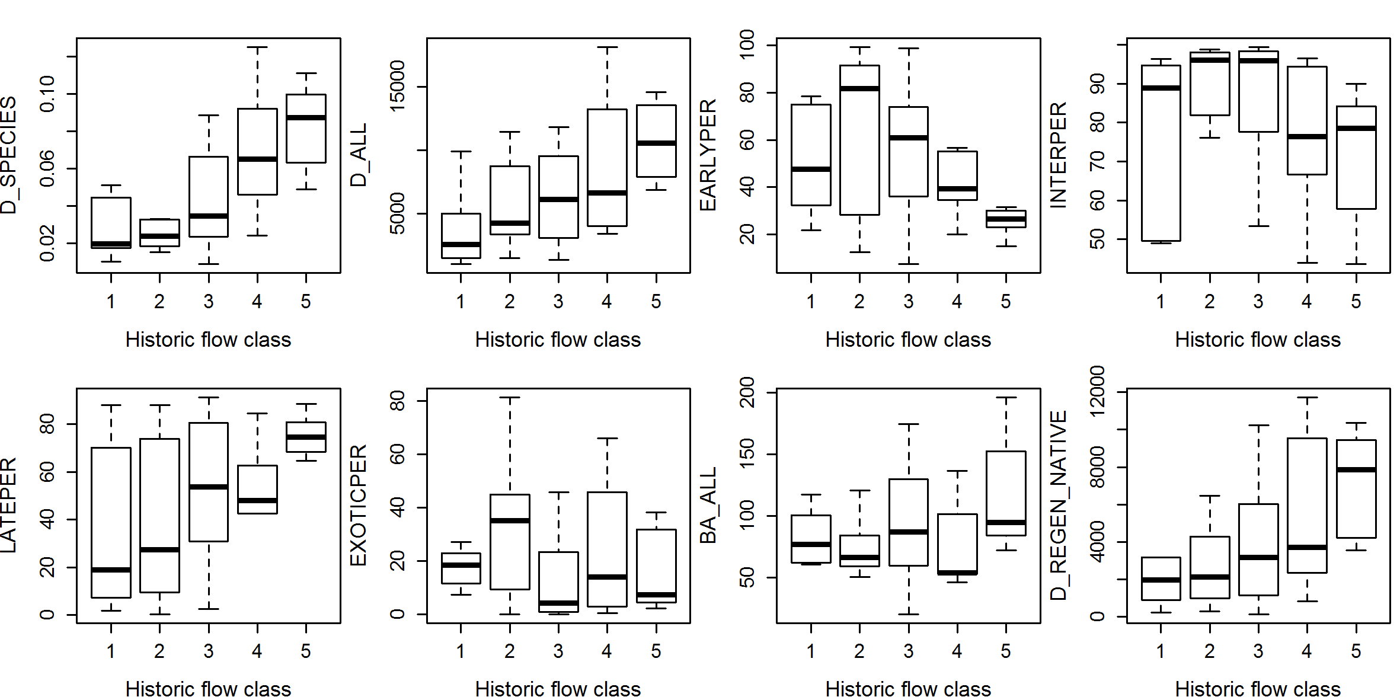

**Figure S2.** Box and whisker plots of abundance (log transformed) of common riparian species across flow classes. Species codes are given in Table S1*.*

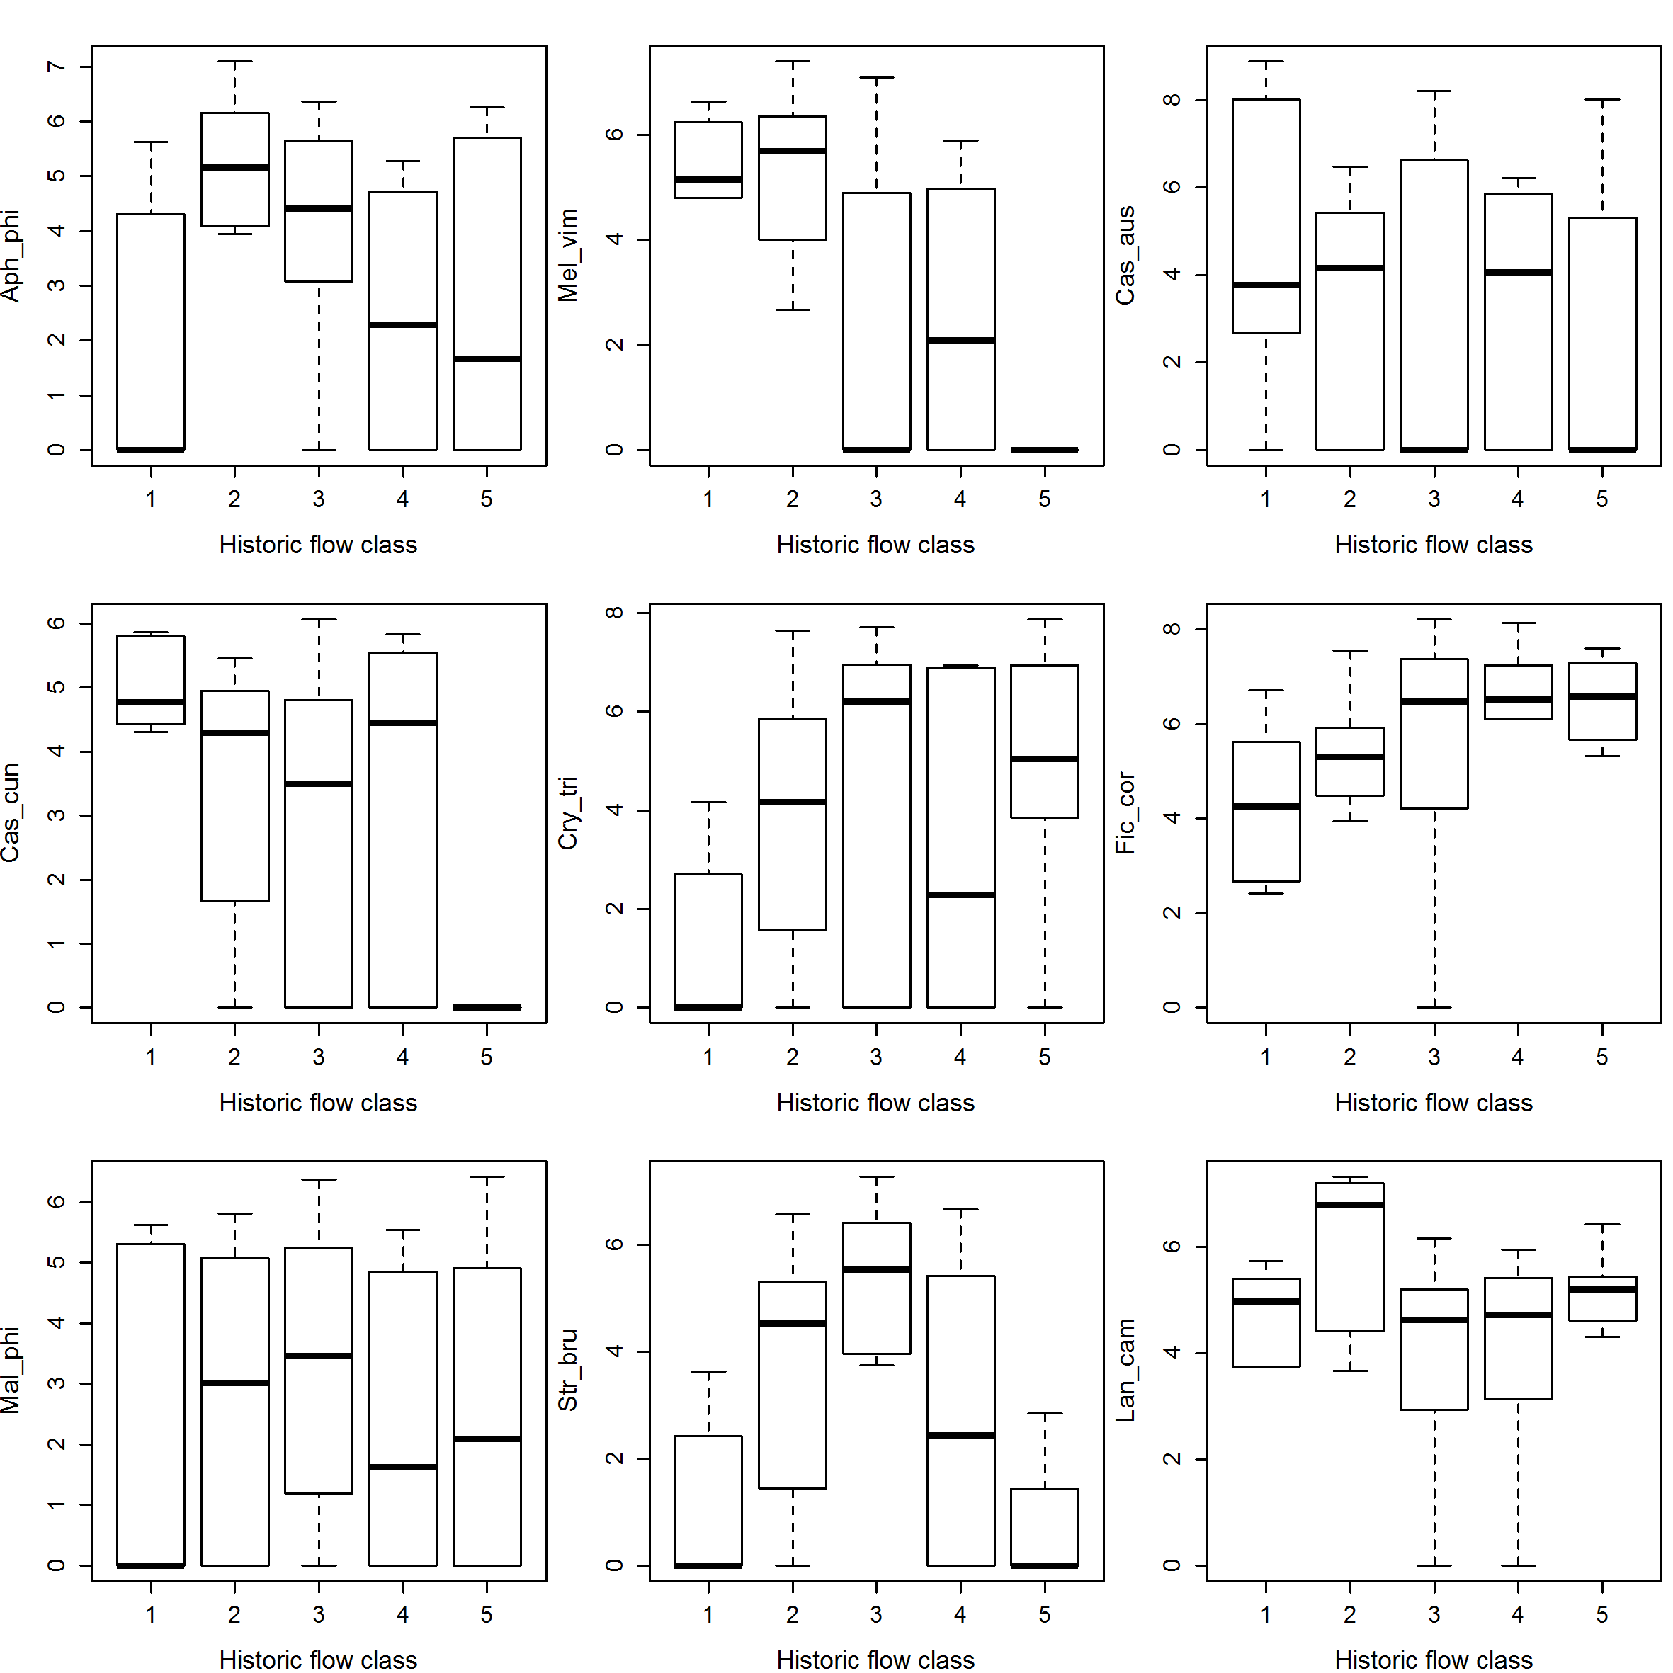

**Figure S3**. Non-metric MDS ordination of sites based on log(*x)* -transformed tree and shrub assemblage data (densities per ha) (x>0), two dimensions. (a) Position of sites and flow classes in ordination space for bank full vegetation, (b) species identified through indicator species analysis as having high habitat fidelity and specificity for the flow classes from the bank full vegetation dataset.(c) position of sites and flow classes in ordination space for near bank vegetation, (c) species identified through the indicator species analysis as having high habitat fidelity and specificity for the flow classes from the near bank vegetation dataset. Species codes are given in appendix Table S2.

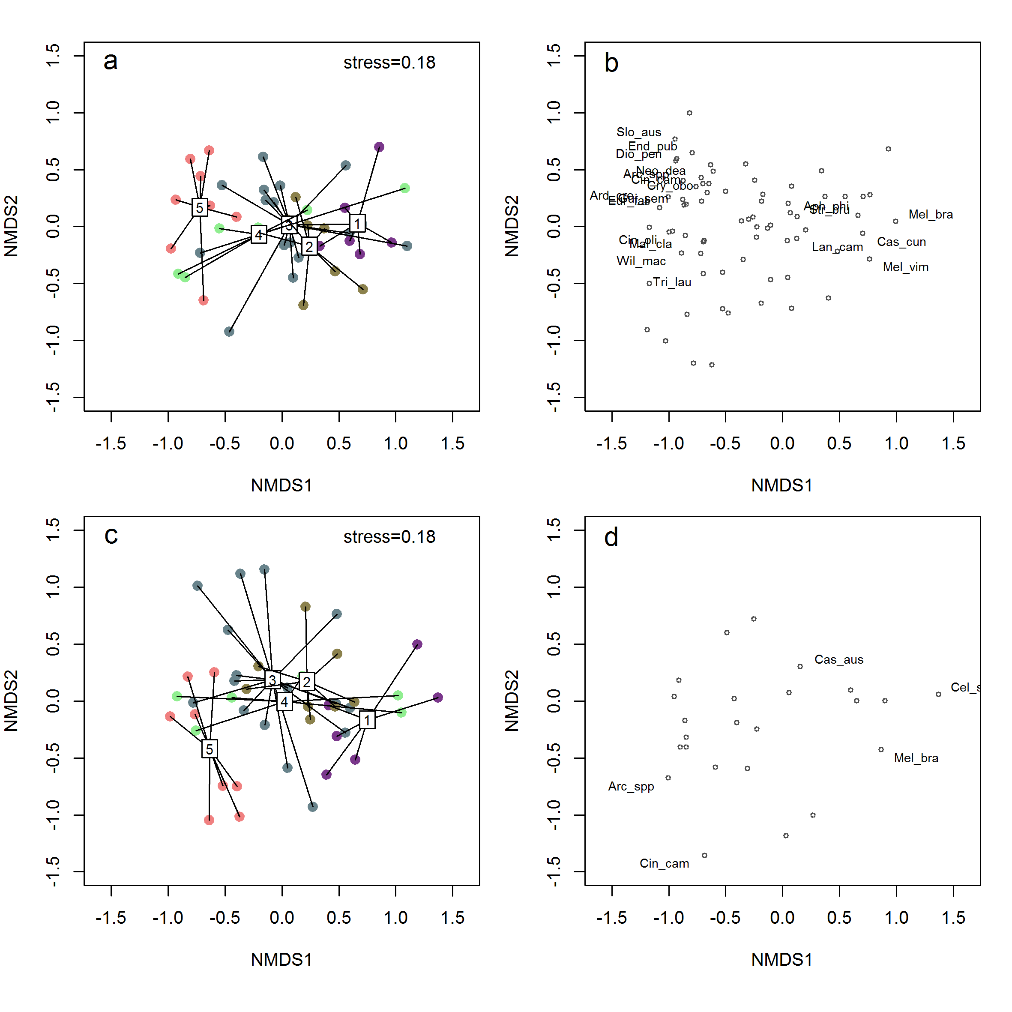

**Figure S4.** Box and whisker plots of (log transformed) environmental variables across flow classes.

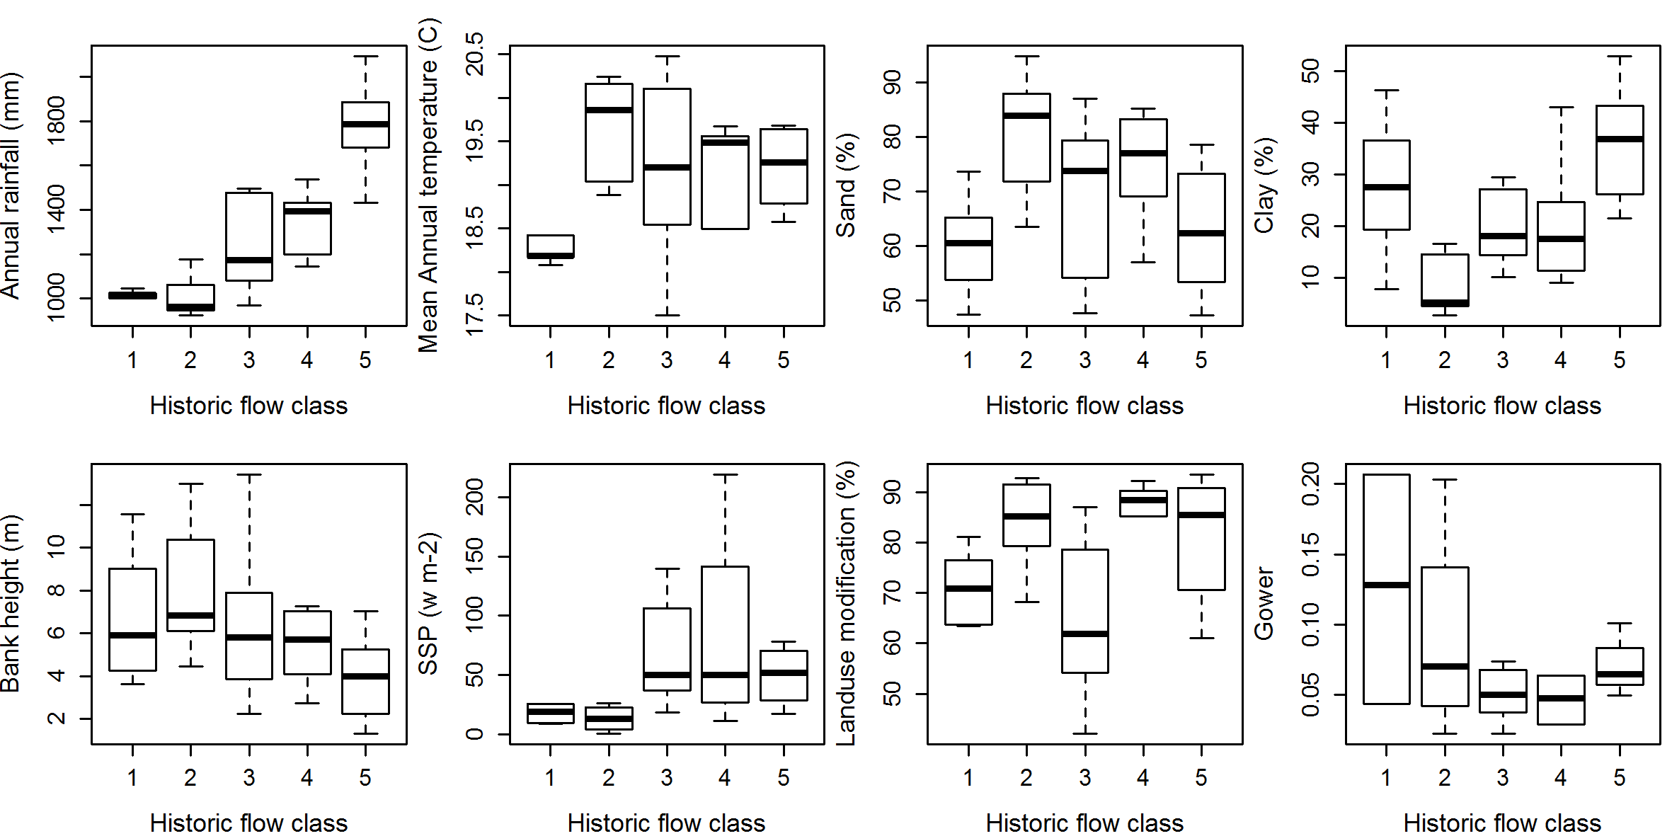

**Figure S5**. Non-metric MDS ordination of sites overlain with individual GAM fitted smooth surfaces of each significant environmental variable. Top row is full bank data and bottom row is near bank data (stress= 0.18).

